PAYMENT OF FEES
The total cost of the conference is 350 EUR and 250 EUR (reduced fee for students, postdocs and accompanying persons). The conference fee will include transportation, full board, welcome party, coffee breaks, conference banquet, etc.
For Polish participants, the conference fee is 1000 zł and 800 zł (reduced fee for students and postdocs).
Students are encouraged to apply for financial support.
Payment of the fee should be made until July 30, 2004.
Bank transfer made without any charge to the beneficiary in Euro (PLN).
Transfer the due amount to:
Holder of the account:
Instytut Fizyki Molekularnej
Polskiej Akademii Nauk
ul. Smoluchowskiego 17
60-179 Poznan, Poland
Name of the bank:
Bank Zachodni WBK S.A. 2 O/Poznan
ul. Jugoslowianska 10, 60-301 Poznan
SWIFT WBKPPLPP
Account no (EUR):
PL93 1090 1346 0000 0000 3423 4292
Account no (PLN):
07 1090 1346 0000 0000 3402 4865
Please, mention CMME’2004 and the name(s) of the participant(s).

LOCATION AND TRAVEL
The location of the meeting is the hotel "Leśny Ośrodek Szkoleniowy" situated in Pusz-czykowo 14 km south of Poznań in the Wielkopolski National Park.
The hotel is located in a pine forest close to the Warta river and within walking distance from the railway station "PUSZCZYKOWO". There are many trains to Puszczykowo departing from the railway station "POZNAŃ GŁÓWNY". Poznań is easily accessible by plane or train. The local airport in Poznań (ŁAWICA) offers several international links. Travel time by train from Warsaw (300 km) and Berlin (280 km) is about 3 hrs.
The organizers will provide a special conference bus on 11th September at 5.00 PM from the Poznań railway station (main entrance), and 6.00 PM from the Ławica airport in Poznań, and from Puszczykowo to Poznań on 15th September at approximately 2.00 PM. Other transportation will be available.

CONTACT
For further information regarding CMME '04 contact the CMME Secretary:

Dr Iwona Olejniczak
Institute of Molecular Physics
Polish Academy of Sciences
ul. Mariana Smoluchowskiego 17
60-179 Poznań, POLAND
Phone: +(48 61) 8 695 271
Fax: +(48 61) 8 684 524
E-mail: cmme@ifmpan.poznan.pl

CONFERENCE
ON NEW CONCEPTS AND MATERIALS

FOR MOLECULAR ELECTRONICS

AND NANOTECHNOLOGY
(CMME '04)
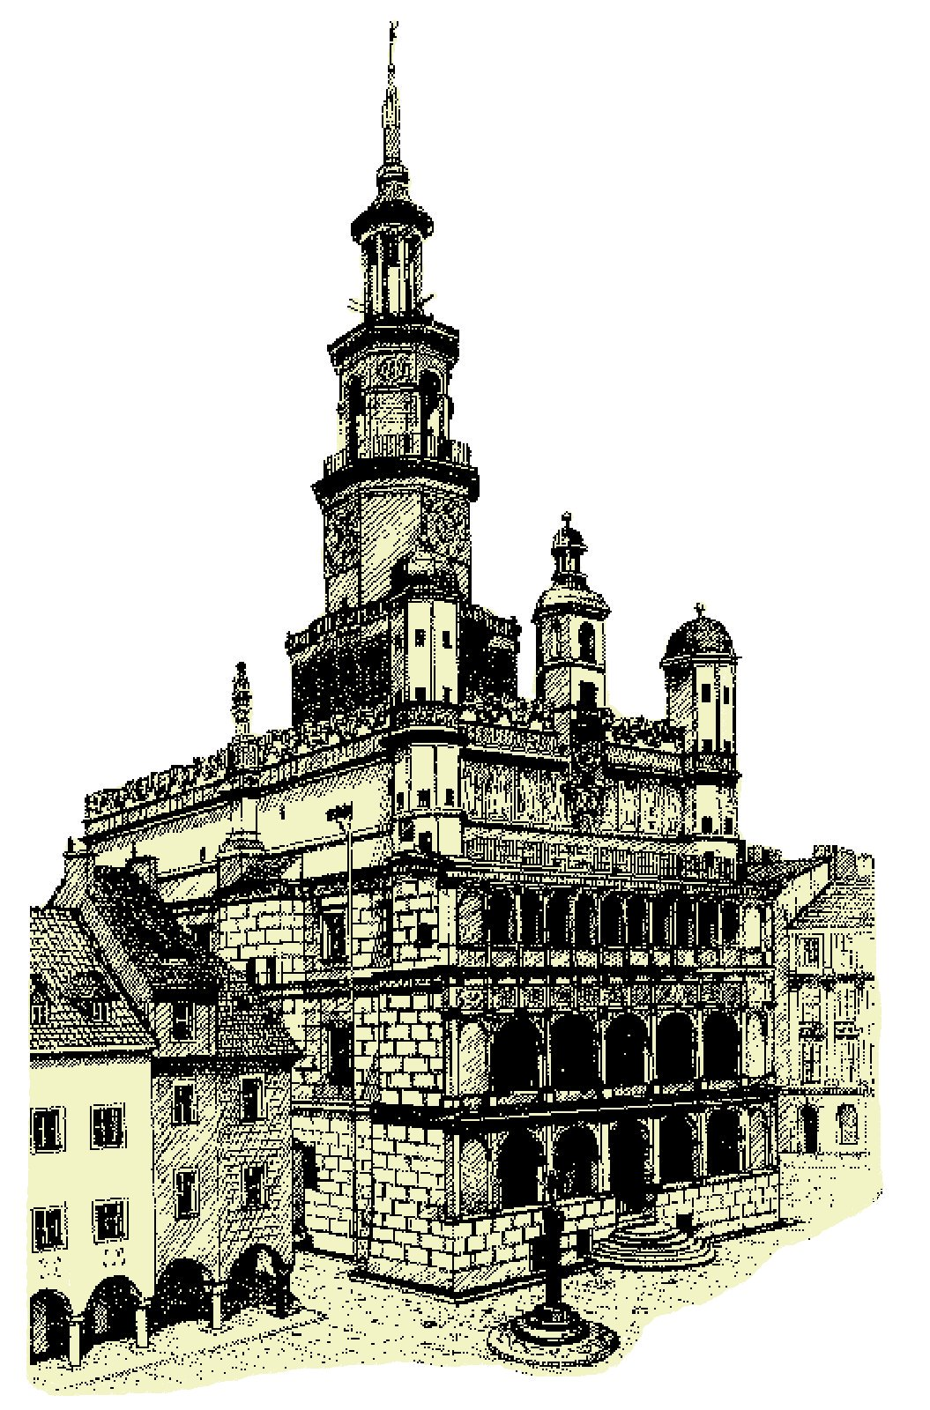
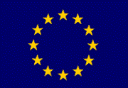


11 - 15 September 2004

Puszczykowo near Poznań

POLAND

Centre of Excellence

for Magnetic and Molecular Materials

for Future Electronics

at the Institute of Molecular Physics

of the Polish Academy of Sciences
(second circular)
ORGANIZERS
Roman Świetlik and Bogdan Bułka

ORGANIZING COMMITTEE
W. Babiaczyk
B. Barszcz
A. Bogucki
B. Bułka (Co-chairman)
A. Graja
A. Łapiński
G. Michałek
I. Olejniczak (Secretary)
R. Świetlik (Chairman)

GENERAL INFORMATION
The CMME conference follows the series of international seminars on highly conducting organic materials for molecular electronics organized by the Institute of Molecular Physics of the Polish Academy of Sciences: Polish - French meetings (Czerniejewo 1985, Nancy 1987, Czerniejewo 1989), Polish - Soviet meetings (Czerniejewo 1988, Chernogolovka 1990, Kiekrz 1992), 4th International Seminar (Zajączkowo 1994), 5th International Seminar (Puszczykowo 1997), and NATO Advanced Research Workshop (Poznań 2001). The detailed scope of these conferences was evolving with time, but it was always focused on molecular electronics and potential applications.
The conference is planned to be an inter-disciplinary meeting of scientists, both theorists and experimentalists, involved in materials science, nanotechnology and processing of molecular devices.
The main objective is to bring together scientists from the European Union and newly associated countries working in the field of molecular electronics and nanotechnology. The conference is also addressed to young researchers and students to present them basic ideas and experience of outstanding scientists.
SCOPE OF THE CONFERENCE
The programme will focus on the following topics:
- fundamental scientific issues for molecular
conductors,
- electron correlations in molecular conductors,
- synthesis, assembly and processing
for molecular systems,
- quantum transport through nanostructures,
magnetic and molecular systems,
- experimental characterization and probes
of molecular structures,
- theory, modelling and simulations
of molecular electronic devices.
The programme will consist of invited (40 min including discussion) and contributed (20 min including discussion) talks as well as poster presen-tations (the maximum size of the poster is: height 1.1 m, width 0.9 m). The official language of the confe-rence is English.

REGISTRATION
On-line registration is preferred. The regis-tration form can be found at the conference website:
http://www.ifmpan.poznan.pl/zp12/cmme/cmme.html
The number of participants is limited to about 60.

ABSTRACTS
For every contribution a one-page abstract (including figures) should be submitted preferably by e-mail or sent by regular mail to the organizers (deadline is: June 15, 2004). Electronic version of the abstract is also required (file format: Microsoft Word for Windows or POSTSCRIPT). The details of abstract preparation can be found at the conference website:
http://www.ifmpan.poznan.pl/zp12/cmme/cmme.html

PROCEEDINGS
Papers presented at the conference and accepted by the referees will be published in a special issue of the international "Materials Science" journal
(http://www.materialsscience.pwr.wroc.pl/) at the be-ginning of 2005.
Estimated length of the manuscript is 16 and 10 pages including figures, tables and references, for invited and contributed papers, respectively. The manuscripts will be typeset by the Publisher and authors should follow the "Instructions for Authors".
The manuscript (three hard copies and a diskette with electronic version) should be delivered to the organizers at the conference desk. The deadline is September 15, 2004.
A copy of the Proceedings will be provided to all registered participants.

INVITED SPEAKERS
G. J. Ashwell (Cranfield)
A. Girlando (Parma)
A. Graja (Poznań)
J. C. (Kees) Hummelen (Groningen)
F. Kajzar (Gif-sur-Yvette)
T. Kostyrko (Poznań)
B. Kramer (Hamburg)
C. Lambert (Lancaster)
T. Luty (Wrocław)
J. L. Musfeldt (Knoxville)
Y. V. Nazarov (Delft)
L. Ouahab (Rennes)
G. Paasch (Dresden)
K. Richter (Regensburg)
D. Schweitzer (Stuttgart)
J. Spałek (Kraków)
J. Sworakowski (Wrocław)
A. Tagliacozzo (Napoli)
J. Ulański (Łódź)
J. Veciana (Barcelona)

