
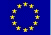
Venue, Accommodation & Travel
Accommodation will be arranged in the House of Creative Work of the Polish Academy of Sciences (Wierzba, 12-222 Wejsuny, Tel. (+48-87) 4231619). Wierzba is surrounded by forests and located on the edge of the great peninsula in between Śniardwy Lake (the greatest in the lake district) Bełdany and Mikołajki Lakes. http://www.wierzba.com.pl/
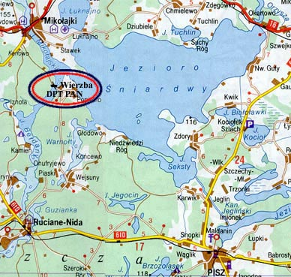
Wierzba can be reached by car or by train from Olsztyn to Ruciane-Nida. We are going to organize the bus transportation from Warsaw on Sunday 09.05.2004 early afternoon; the details will be given later.

Fee
The Fee is 225 € and will include the full board, accommodation and booklet of Abstracts. The Fee should be transferred to the Bank B2 WBK 2/O Poznań on account number 93 1090 1346 0000 0000 3423 4292 in € and the number 07 1090 1346 0000 0000 3402 4865 in PLN, or paid at the registration desk (230 €).
Ph.D. students contributing a poster may apply for a reduction of the Fee.

Accompanying Scientific Event
The School will be followed by the XVI Polish-Czech Seminar on Structural and Ferroelectric Phase Transitions organized by the same place from May 13 – 15, 2004. The Fee for the both events (the School (PCMR) and Polish-Czech Seminar) amounts to 330 €.
School on
POLYMERS AND COMPOSITES
FOR MICROELECTRONICS
AND ROBOTICS
(PCMR)
May 10-13, 2004
Great Mazurian Lakes
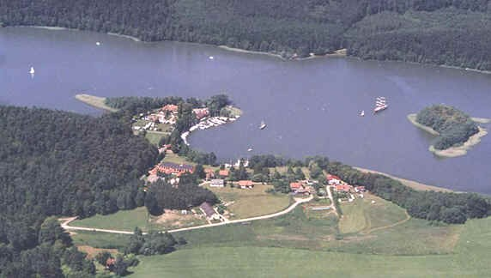

Centre of Excellence
for Magnetic and Molecular Materials for Future Electronics (MMMFE)
at the Institute of Molecular Physics, PAS
M. Smoluchowskiego 17
60-179 Poznań, Poland
http://www.ifmpan.poznan.pl/zp4/school/place.html
Second Circular

School on Polymers and Composites
for Microelectronics and Robotics
is organized in the frame of Centre of Excellence for Magnetic and Molecular Materials for Future Electronics (MMMFE) at the Institute of Molecular Physics, PAS. The main objective of the School is to bring together scientists from the EU and newly associated countries involved in research and application of polymers and their composites. The School is also addressed to young scientists (students, Ph.D. students and post-docs), and aims at acquainting them with theoretical, experimental and technological methods used in the physics of these materials.

Main Topics
- ferroelectrics polymer and polymer relaxors
- polymer-ceramic composites
- low-permittivity materials
- conducting polymers and composites
- basic properties of polymers and composites
- applications
Format
The Scientific Program will contain
- invited tutorial lectures (90 mins),
- oral contributions (25 mins),
- posters commenced with brief oral presentation (5 mins) during the poster session.

Invited Speakers
The following have already agreed to give invited lectures:

S. Bauer (Linz, Austria) J.K. Krüger (Saarbrücken, Germany)
M.D. Glinchuk (Kiev, Ukraine) J. Petzelt (Prague, Czech Republic)
S.K. Hoffmann (Poznań, Poland) P. Pierański (Poznań, Poland)
R. Kimmich (Ulm, Germany) A. Safari (Piscataway, USA)

Abstracts Instruction
Abstract booklet will contain Extended Abstracts of tutorial lectures (4 pages) and oral contributions (2 pages) and one-page Abstracts of Posters. The Abstracts are to be submitted before March 1, 2004 by e-mail to bhilczer@ifmpan.poznan.pl as MS-Word-attachment and followed by the original camera-ready version.

INSTRUCTION FOR PREPARING CONTRIBUTION FOR THE EXTENDED ABSTRACT BOOKLET

P. Pierański¹, B. Hilczer²
¹Department of Technical Physics, Poznan University of Technology
60-965 Poznań, Poland
²Institute of Molecular Physics, Polish Academy of Sciences
60-179 Poznań Poland

The text must fit into the area of 16cm×24cm. The centered title in all capital letters is followed by the authors name(s) (12-point size, bold Times New Roman) and by the Authors affiliation (12-point size Times New Roman). The name of the Presenting Author should be underlined. Insert a blank line between the title and the names. The text, single spaced, begins one blank line after the author affiliations, indented 5 spaces. Figures must be the proper position and size in the text. Reference number should appear in square brackets [1].

[1] References are separated from the text by a blank line.

Deadlines
Preliminary Registration February 1, 2004
Submission of Abstracts March 1, 2004

Organizers
Centre of Excellence for Magnetic and Molecular Materials for Future Electronics (MMMFE) at the Institute of Molecular Physics, Polish Academy of Sciences, M. Smoluchowskiego 17, 60-179 Poznań, Poland.
Bożena Hilczer (Chair), bhilczer@ifmpan.poznan.pl
Czesław Pawlaczyk (Secretary), czpawl@ifmpan.poznan.pl

