INTRUDUCTION FOR PREPARING CONTRIBUTION FOR THE ABSTRACT BOOKLET {12 pt}

A. Author¹, B. Author^{1,2} and C. Author³ {12 pt}
¹ Institute for X Studies, University X, Town X, Country X {10 pt}
² Institute for Y Studies, University Y, Town Y, Country Y
³ Institute for Z Studies, University Z, Town Z, Country Z
e-mail of the presenting author {10 pt}

Abstracts should be written within a single page. Please select the A4 paper size (21.0 × 29.7 cm). Type within 2.5 cm margins top/bottom and left/right. Use Times New Roman 12 pt font and single line spacing. The title of an abstract should be written in bold capital letters and centered. There should be one empty line left between the title and the authors’ names. The authors’ names, their affiliation (institution) and addresses should be centered, too (10 pt font size, italics). The name of the presenting author must be underlined.
Leave also a blank line between: the e-mail address and the main body of text, main body of text and figure, figure and references. Reference number should appear in square brackets [1]. MS Word DOCX files are preferred, although MS Word DOC will also be accepted.

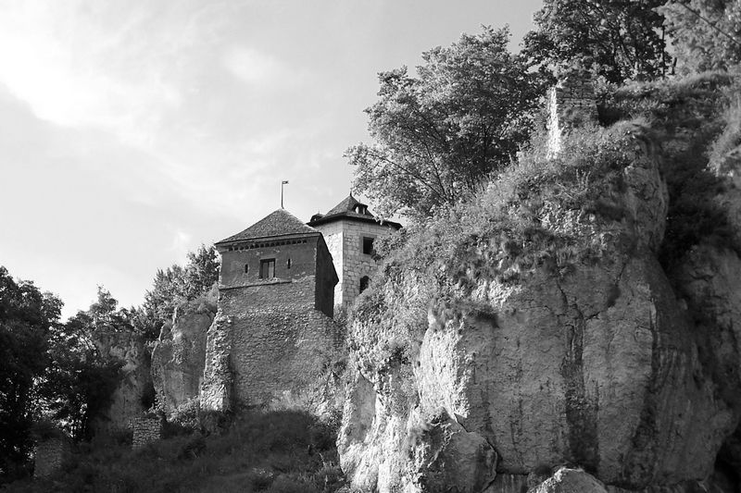
Fig. 1. Figures (grayscale, keep to a minimum of 300 dpi) must be the proper position and size in the text (10 pt, bold, to the left). {10 pt}

References {12 pt}
[1] Author H, Author ME and Author HM: Title. Journal Name. Year;Volume:page i
[2] Author AB, Author J and Author DL: Book Title. Place of Publication: Publishing Company; Year;page i
[3] Author AD, Chapter Title. In: Editor AB, Editor DE, eds. Book Title. Place
of Publication: Publishing Company; Year;page i

