Title of the abstract

A. B. Presenting-Author¹, C. Author², D. E. Author¹
¹Institute of Molecular Physics, Polish Academy of Sciences, Poznan, Poland
²Another Institute for Other Studies, Anytown, Anyland
corresponding_author@email.address

We would like to ask you to prepare your abstracts as Microsoft Word document according to the present example.
The abstract should be typed in English language as one A4 page
(with 35 mm left margin and 25 mm others) using Times New Roman font and single line spacing. Only the title should be written as bold in 16pt font size. The rest of the text must be typed in 12pt size. The title, authors names, affiliations and corresponding author email – centered. The presenting author should be underlined whilst affiliations and corresponding author email address typed in italics.
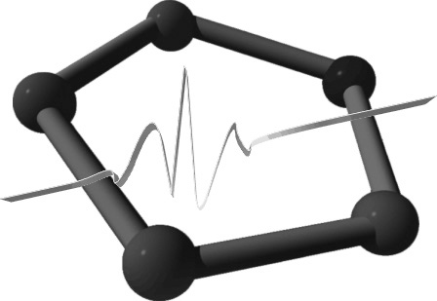
The main text of abstract may contain tables or figures – Fig. 1. During prepare figures please remember, coloured pages will be printed as black and white copies.
The references should be in form shown below [1].

Fig. 1. Black and white figure

Submission: The abstracts should be sent to RAMIS-2007 office address: ramis@ifmpan.poznan.pl before March 31, 2007.

[1] Author A., Author B. C., Author D.: Appl. Magn. Reson. 4, 1–11 (2007)

