 | Summer School on  NEW MAGNETICS  September 15-19, 2003  Będlewo near Poznań, Poland | 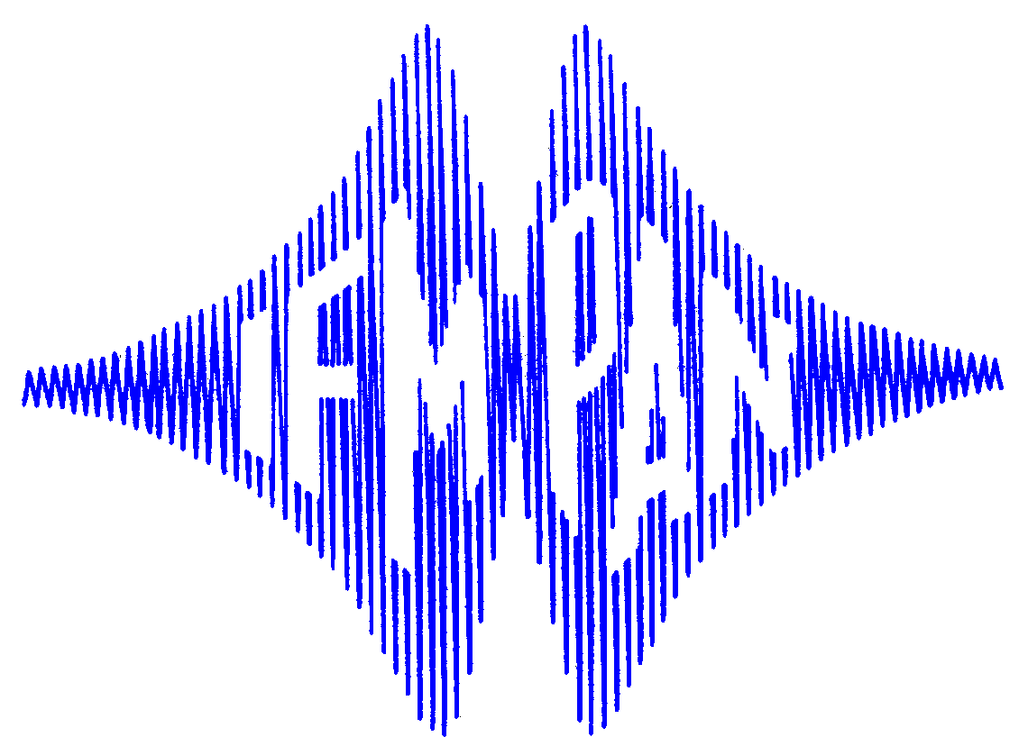

SCHEDULE

Sunday, 14 September

16.00-18.00 Transportation to Będlewo and Registration
19.00 Reception and get-together

Monday, 15 September

8.50- 9.00 OPENING

Chairman: W. Temmerman
9.00-10.30 J. Hafner First-principles investigations of magnetic nanostructures
10.30-11.00 Coffee
11.00-12.30 H. Kroha Nonlinear transport of electrons and spins in correlated mesoscopic
structures
12.30-13.00 M. Kosuth Electronic, magnetic and transport properties of
ferromagnet-semiconductor heterostructure systems
13.00-14.00 Lunch

Chairman: J.A. Morkowski
14.30-16.00 L. Nordstroem Unconstrained non-collinear calculations of complex magnetic
materials
16.00-16.30 Coffee
16.30-18.00 J.M. Greneche Nanocrystalline alloys: structural aspects and magnetic properties
18.00-18.30 A. Postnikov Ab-initio simulations of molecular magnets
19.00 Dinner

Tuesday, 16 September

Chairman: K.-H. Mueller
9.00-10.30 R. Wiesendanger Frontiers of nanomagnetism investigated by spin- polarized
scanning tunneling spectroscopy
10.30-11.00 Coffee
11.00-12.30 H. Eschrig Relativistic density funcional approach and magnetism
12.30-13.00 J. Hafner Non-collinear magnetism and phase-stability of Mn
13.00-14.00 Lunch

Chairman: R. Wiesendanger
14.30-16.00 K. Baberschke The magnetism of ultrathin trilayers: A playground to study
fundamentals
16.00-16.30 Coffee
16.30-18.00 D. Szotek SIC-LSD description of half-metallic transition metal oxides
18.00-18.30 M. Richter Magnetocrystalline anisotropy of strained transition metals
and rare-earth intermetallics: density functional calculations
19.00 Dinner

20.00-22.00 Posters

Wednesday, 17 September

Chairman: J. Hafner
9.00-10.30 J. Kirschner Recent developments in nanoscale magnetism
10.30-11.00 Coffee
11.00-12.30 H. v. Loehneysen Heavy fermion systems near a magnetic instability
12.30-13.00 M. Przybylski Fe-based spin aligners grown on semiconducting substrates
13.00-14.00 Lunch

Chairman: H. von Loehneysen
14.30-16.00 H. Ebert Magnetic and spectroscopy properties of free and supported transition
metal clusters
16.00-16.30 Coffee
16.30-18.00 K.-H. Mueller Magnetism in low-dimensional cuprates
18.00-18.30 F. Stobiecki Magnetoresistance of Ni₈₀Fe₂₀/Au/Co/Au multilayers
18.30-19.30 Oral Session (M. Zwierzycki / J. Dubowik / B. Idzikowski)
20.00 Banquet

Thursday, 18 September

Chairman: H. Eschrig
9.00-10.30 S. Bluegel Magnetism under the scanning tunneling microscope
10.30-11.00 Coffee
11.00-12.30 W. Temmerman Self interaction corrected electronic structure calculations for
correlated systems
12.30-14.00 V. Eyert Ab-initio calculations for low-dimensional magnetic systems
14.00-15.00 Lunch

Chairman: K. Baberschke
15.30-17.00 F. Petroff Magnetic tunnel junctions: review of experimental results and
perspectives
17.00-17.30 Coffee
17.30-19.00 T. Jungwirth Transport and magnetic properties of ferromagnetic (III,Mn)V
semiconductors
19.30 Bonfire

Friday, 19 September

Chairman: S. Bluegel
9.00-10.30 O. Eriksson Electronic structure of dilute magnetic semiconductors
10.30-11.00 Coffee
11.00-12.30 A. Ślebarski Electronic structure and thermodynamical properties of some
ternary d and f electron intermetallics
12.30-13.15 J.A. Morkowski Fast magnon relaxation
13.15-13.45 S. Krompiewski Ferromagnetically contacted metallic carbon nanotubes with
spin-selective interfaces
14.00-15.00 Lunch
15.00 Excursion

20.00 Dinner

