The European Conference
PHYSICS OF MAGNETISM’02
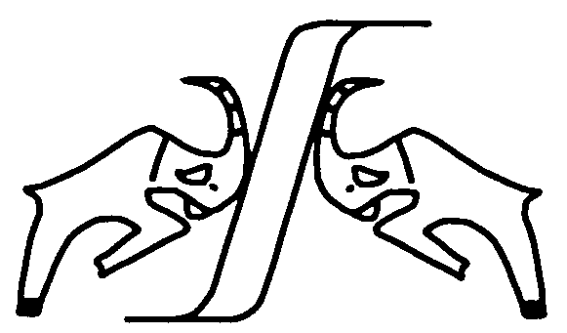 | July 1-5, 2002  Poznań, POLAND
CELEBRATING THE 50th ANNIVERSARY OF THE POLISH ACADEMY OF SCIENCES
Chairmen:
A. Jezierski, Institute of Molecular Physics, Polish Academy of Sciences, Poznań
R. Micnas, Institute of Physics, Adam Mickiewicz University, Poznań
Programme Committee:
O.K. Andersen, Stuttgart, Germany | P. Horsch, Stuttgart, Germany | G.A. Sawatzky, Groningen, The Netherlands
J. Baszyński, Poznań, Poland | J. Klamut, Wrocław, Poland | T. Schneider, Zürich, Switzerland
B. Fechner, Poznań, Poland | L. Kowalewski, Poznań, Poland | J. Sólyom, Budapest, Hungary
A. Fert, Orsay, France | J. Kuebler, Darmstadt, Germany | J. Spałek, Kraków, Poland
J. Flouquet, Grenoble, France | P.A. Lindgård, Roskilde, Denmark | H. Szymczak, Warszawa, Poland
P. Fulde, Dresden, Germany | P. Littlewood, Cambridge, U.K. | A. Szytuła, Kraków, Poland
R. Gałązka, Warszawa, Poland | J.A. Morkowski, Poznań, Poland | R. Troć, Wrocław, Poland
P. Gruenberg, Juelich, Germany | H. Puszkarski, Poznań, Poland | Y.J. Uemura, New York, USA
B.L. Gyorffy, Bristol, U.K. | J. Ranninger, Grenoble, France | L. Wojtczak, Łódź, Poland

Invited speakers include:
B. Andraka, Gainesville, USA | D. Kaczorowski, Wrocław, Poland | I. Škorvanek, Košice, Slovakia
K. Baberschke, Berlin, Germany | B. Keimer, Stuttgart, Germany | T. Story, Warszawa, Poland
J. Barnaś, Poznań, Poland | C.L. Lacroix, Grenoble, France | W.M. Temmerman, Warrington, U.K.
G. Borstel, Osnabrueck, Germany | R.B. Laughlin^{(*)}, Stanford, USA | I. Turek, Brno, Czech Republic
A. Bussmann-Holder, Stuttgart, Germany | G.G. Lonzarich, Cambridge, U.K. | P. Wachter, Zürich, Switzerland
P. Coleman, Piscataway, USA | W. Nolting, Berlin, Germany | P.E. Wigen, Columbus, USA
S.C. Erwin, Washington DC, USA | A.M. Oleś, Kraków, Poland | K.I. Wysokiński, Lublin, Poland
J. Franse, Amsterdam, The Netherlands | G. Reiss, Bielefeld, Germany | J. Zaanen, Leiden, The Netherlands
J.K. Freericks, Washington, USA | A. Simon, Stuttgart, Germany | ^{(*)} to be confirmed

The Conference PHYSICS OF MAGNETISM'02 will be the tenth of the series organized, every three years since 1975, jointly by the Institute of Physics of the Adam Mickiewicz University and the Institute of Molecular Physics of the Polish Academy of Sciences in Poznań. The Conference is meant as an international forum for the presentation and discussion of novel scientific ideas, in a field of broadly understood magnetic phenomena (including experimental results and new materials) with special emphasis on the following subjects: novel metallic oxides and anomalous magnetoresistive materials; low dimensional quantum magnets; heavy fermions, fluctuating valence and Kondo systems; magnetic multilayers, surfaces, and nanostructures; high temperature superconductors; electronic structure.
The main objective of the Conference is to bring together scientists and technologists from the Western, Central and Eastern European countries involved in research and application of new magnetic materials and high temperature superconductors. The scope of the Conference is quite wide and covers: high-T_{C} superconductors, heavy fermions, mixed valence, rare-earth and actinides, quasi-1D and -2D magnets, disordered and amorphous magnetic alloys, magnetic semiconductors etc.
The plenary talks are to be presented by the invited distinguished scientists from all over the world. The programme of 5-days Conference is planned to consist of 28 plenary talks and about 300 oral and poster contributed papers. The proceedings containing plenary talks and selected papers will be published as a regular issue of physica status solidi (a)

Information → http://www.ifmpan.poznan.pl/zp2/pm02.html

Secretaries:
A. Szajek | R.J. Wojciechowski
Institute of Molecular Physics | Institute of Physics
Polish Academy of Sciences | Adam Mickiewicz University
-----------------------------------------------------------------------------------------------------------------------------------------------------------------------------------------------------------------------------------------------------------------------------
Smoluchowskiego 17, 60-179 Poznań, Poland |  | Solid State Theory Division
Phone: +48-61-8695 121 |  | Umultowska 85, 61-614 Poznań, Poland
Fax: +48-61-8684 524 |  | Phone: (+48-61)-8273041, 8273052, 827343
 | or | Fax: +48-61-8257 758
Email: pm02@ifmpan.poznan.pl |  | Email: rom@alpha.amu.edu.pl
SPONSORS
European Science Foundation
Ministry of National Education and Sport
Polish Academy of Sciences
A.B.E. MARKETING - Publishers' Distribution Services

